Structure analysis calculator:

Powerful tool for engineers, architects

and researchers can use to evaluate the behaviour

of different kinds of structures.

Structure analysis calculator: Powerful tool for engineers, architects and researchers can use to evaluate the behaviour of different kinds of structures.

Calculator is a specialized tool designed for the analysis and design of structural elements, such as beams, columns, shafts, and members of varying cross-sections.

This calculator makes it easier to analyse and optimise section properties in detail for structural integrity, efficiency, and safety in a variety of construction projects

Easily calculate and visualize the geometric properties of various cross-section shapes, including moments of inertia, section moduli, centroidal distances, and other critical parameters essential for structural analysis and design.

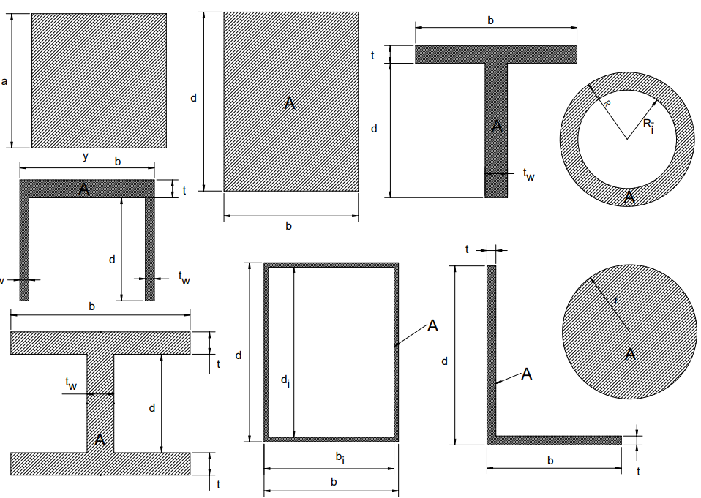Area of section(A):

Total amount of space inside the section.

Drop down:

What are the significance of area of sections?

Used for calculations of stress, strain, and moments of inertia.

What are the inputs to calculate the area of section?

dimension of cross section

how to calculate the area of cross section?

Area of section for various cross section can be calculated by using these formulas:

1. Square: A=A2

2. Rectangle: A=dxb

3. Hollow rectangle: A=(dxb) – (dixbi)

4. Circle: π×r2

5. Hollow circle or pipe: A=π(R-Ri)

6. L bar: A=t(b+d−t)

How to find L bar area

Consider we have two different rectangle having length =d&b & width t for both rectangle

A=A(rectangle1) + A(rectangle1) – area of intersecting of both rectangle

A=bt+dt-txt

A=t(b+d−t)

7. I beam: A=twd+2tb

How to find I bean area

Consider we have three rectangle

Rectangle X (web) having length =d & width = tw

Rectangle y & z (flanges) having same length =b & width = t

Area(A)= A(rectangle X) + A(rectangle Y) +A(rectangle Z)

A= twd+tb+tb

A=twd+2tb

8. C channel: A=tb+2twd

How to find C channel area

Consider we have three rectangle

Rectangle X (web) having length =b & width = t

Rectangle y & z (flanges) having same length =d & width = tw

Area(A)= A(rectangle X) + A(rectangle Y) +A(rectangle Z)

A= tb + twd + twd

A=tb+2twd

9. T section: A=tb+twd

How to find T section area

Consider we have two different rectangle

Rectangle X (flange) having length =b & width = t

Rectangle y (web) having same length =d & width = tw

A=A(rectangleX) + A(rectangleY)

A=bt+ twd

A= tb+twd

What are the units of area of cross section?

S.I Units of area is mm2

Imperial Units of area is in2.

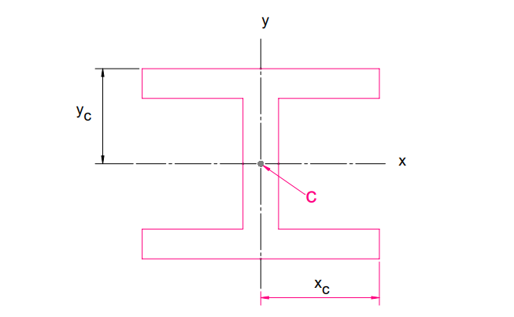Principle axis: Main axes of cross section or

member which are perpendicular and intersect each other at the center of area or centroid.

Centroid: Center of mass for the geometric shape

or point within the section where the area could be

balanced without any rotation.

Drop down:

What are the significances of centroid:

1. Used to find moment of inertia.
2. Centroid is crucial for designing stable structures.
3. For determining the location of the neutral axis of section or member.

What are the inputs to calculate centroid?

dimensioms for cross sections

how to calculate the centroid of section?

Centroid of various section can be calculated by using these formula

1. Square: yc​=xc​=a/2
2. Rectangle: *Xc*​=*b*/2 & yc=d/2
3. Hollow rectangle: *Xc*​=*b*/2 & yc=d/2
4. Tee section: yc​=(bt2+tw​d(2t+d)​)/ 2(tb+tw​d) & xc​=b/2
5. Channel section: yc​=(bt2+2tw​d(2t+d)​)/ 2(tb+2tw​d) & xc​=b/2
6. Wide-flange beam: xc​=b/2 & yc​=d/2+t
7. Angle: xc​=(b2+dt−t2)/(2(b+d−t)​) & yc=(d2+bt-t2)/(2(b+d-t))
8. Circle: yc​=xc​=R
9. Hollow circle or pipe: yc​=xc​=R

What are the units of centroid?

S.I Units of centroid is mm

Imperial of centroid is mm.

Area Moments of Inertia (Ix, Iy) (second moment of area):

Measures of the distribution of area around the

centroidal axes. Indicate the section's resistance to

bending and torsion about its principal axes.

Drop down:

geometrical property that Reflects how the area of a cross section is distribute relative to particular axis and Measure of cross section resistance to bending due to its shape.

What are the significance of area moment of inertia: Resistance of an area against the applied moment (bending or twisting moment) about an axis.

What are the inputs to calculate area moment of inertia?

dimensions of cross section

how to calculate area moment of inertia?

Area moment of inertia can be calculated by using these formulas

formula: Ix= ∫y2dA & Iy= ∫x2dA

Where y = distance from the x axis to area dA

x = distance from the y axis to area dA

formulas for various sections:

1. square Ix​=Iy​=a4/12
2. rectangle: Ix​=bh3/12, Iy​=db3/12
3. hollow rectangle: Ix​=(bd3-bidi3)/12 & Iy​=(db3-dibi3)/12
4. t section: Ix​=(b(d+t)3-d3(b-tw))/3 – A(d+t-yc)2 & Iy​=(tb3+dtw2)/12
5. c channel: Ix​=(b(d+t)3-d3(b-2tw))/3 – A(d+t-yc)2 & Iy=((d+t)b3-d(b-2tw)3)/12
6. I beam: Ix=(b(d+2t)3-(b-tw)d3)/12 & Iy=(b3t)/6 + (tw3d)/12
7. L angle: Ix​=(bd3-(b-t)(d-t)3)/3 – A(d-yc)2 & Iy​=(db3-(d-t)(b-t)3)/3 – A(b-xc)2
8. Circle: Ix​=Iy​= πR4/4
9. Hollow Circle: Ix​=Iy​= π(R4-Ri4)/4

What are the units of area moment of inertia?

S.I Units of area moment of inertia is mm4.

Imperial units of area moment of inertia is in4 .

Section modulus: Geometrical property of cross

section used to design beam or flexural member. Measure

section's ability to resist bending or flexural deformation.

Drop down

What are significance of section modulus:

1. It tell us about the strength of beam, higher section modulus means high strength of the beam.
2. Higher section modulus indicates greater resistance to bending, making it a crucial factor in designing structures.

What are the requirements or input to calculate the section?

1. Dimensions of Cross section.
2. maximum distance from the neutral axis to the surface of the member

how to calculate section modulus?

Section modulus can be calculated by using the formula:

s = I/c

Where I is second moment of inertia (area moment of inertia)

& c is maximum distance from the neutral axis to the surface of the member.

Formulas for various section :

1. Square: sx=sy=ix/yc=a3/6
2. Rectangle: sx=ix/yc=bd2/6 & sy=iy/xc=db2/6
3. Hollow rectangle: sx=ix/yc  & sy=iy/xc
4. Tee section: sx=ix/d+t-yc & sy=iy/xc
5. C channel: sx=ix/d+t-yc & sy=iy/xc  , A=tb+2tw​d
6. I section: sx=ix/yc  & sy=iy/xc
7. L angle: sx=ix/d-yc  & sy=iy/b-xc , A=t(b+d-t)
8. Circle: sx=sy=ix/yc=π​R3/4
9. Hollow circle or pipe: sx=sy=ix/yc

What are the units of section modulus?

S.I Units of section modulus is mm3.

Imperial units of section modulus is in3.

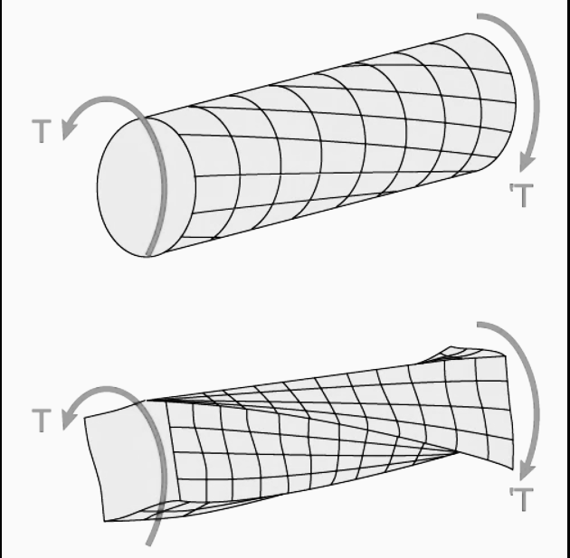

Torsional constant:

Geometrical property of bar cross section that describes

its resistance to torsional deformation during torsion.

dropdown

what are the Significance of torsional constant:

Crucial for designing shafts that transmit power in machinery. Knowing the torsional constant allows for the design of shafts that can safely transfer torque without excessive twisting or failure.

how to calculate torsional constant?

Torsional constant can be calculated by using the formula:

ϕ=TL/kg or k =TL/ ϕg

​In this equation:

ϕ — Angle of twist;

T — Torque applied to the beam;

L — Shaft length;

G — Shear modulus of the shaft material

K — Beam torsional constant, the one we get with this calculator.

The torsional constant in this formula has the same function as the polar moment (polar moment of inertia - describes a cross sections resistance to torsion due to its shape or measure the strength (max. applicable torque) of shaft )circular beam, but we termed it here with the

K symbol to differentiate both.

Formula for various sections:

1. Circle: K= (πr4)/2
2. Ellipse: k=(πa3b3)/ (a3 + b3)
3. Hollow ellipse k=((πa3b3) (1- q4))/ (a3 + b3) where q = a0/a = b0/b
4. Thin walled ellipse: k=(4π2t(a-t/2)2(b-t/2)2)/U whereu is length of median, U=π(a+b−t)(1+(0.258(a-b)2)/(a+b-t)2)
5. Square: K=9a4/64
6. Rectangle: k=ab3/3 - 0.21b4+0.0175b8/a4
7. Hollow walled rectangle: (2tt1(a−t)2(b−t1)2)/(at+bt1-t2-t12)
8. I section: K=2K1+K2+2αD4

K1=(ab3)/3 – 0.21b4 + 0.0175b8/a4

K2=cd3/3

D=t/t1(0.15+0.1r/b)

α = t/t1(0.15+0.1r/b)

if b<d, then t/t1= b/d

if b>d, then t/t1= d/b

What are the units of torsional constant?

S.I Units of torsional constant is mm4.

Imperial units of torsional constant is in4

Radius of gyration(k): distance at which entire area of cross

section has to be conertrated in thin strip in order to get the

same moment of inertia.

Drop down

Formula: kx=(Ix/A)1/2

Ky=(Iy/A)1/2

warping constant

Measure of the resistance of the cross-section to warping due to torsion, and it varies with the shape and sizes of the cross-section.

Shear center

point that doesn’t experience rotation when beam is subjected to torsion

Plastic section modulus